**Handling User Authentication**

**Code:**

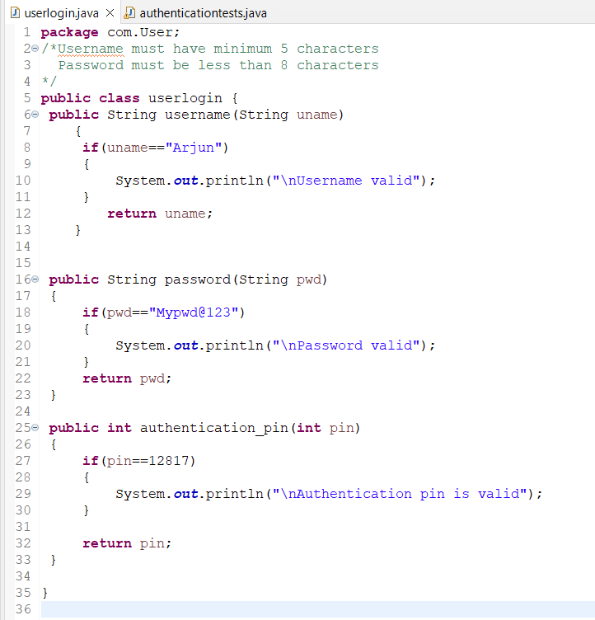

**Junit tests:**

**Checking Username**

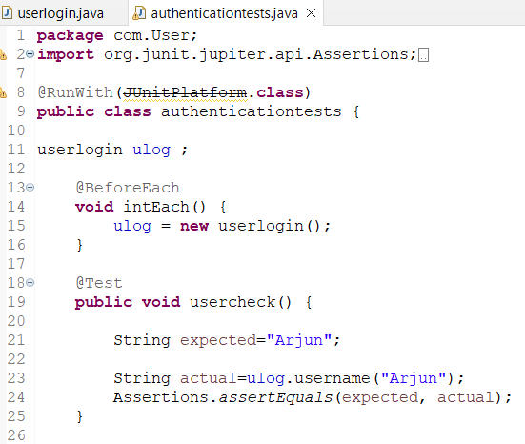

**Checking Password:**

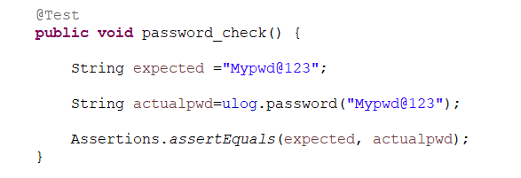

**Checking Authentication pin:**

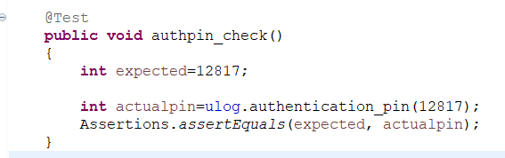

**Unit test for validation of username:**

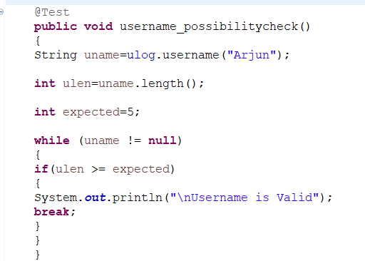

**Unit test for validation of password:**

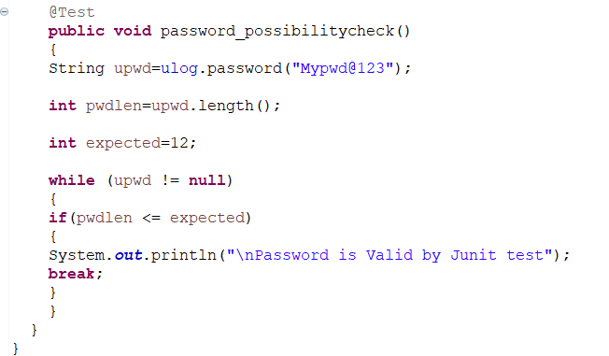

**Output:**

